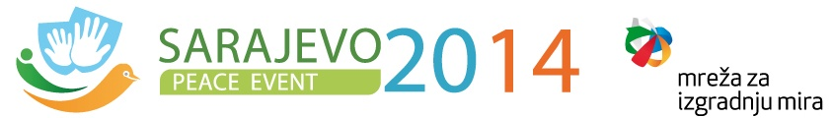
www.peaceeventsarajevo2014.eu

19.05.2014

Dear ladies and gentlemen,
It is with great concern and consternation that we have learned about the numerous victims and tremendous destructions due to the flooding in the Balkans and especially in Bosnia-Herzegovina.
We would like to express our deepest sympathy and sincere support to those, who suffer from the consequences of these worst flooding in over a century in the region.
Preparing the Peace Event, which will take place in Sarajevo from 6th to 9th of June, we turn to all organizations, initiatives and partners supporting this international Event: Please help with both monetary and material donations! The long-suffering people in Bosnia-Herzegovina need our support and assistance.
This short letter is an expression of our deepest solidarity with the citizens of Bosnia- Herzegovina and a small token of sympathy and compassion.
Sincerely yours,
The International Coordinating Committee of the Peace Event Sarajevo 2014

